1. Write the query to display productionid, production name with total number movies produced by each.

>select productions.productionname,movie.productionid,count(\*)

from movie

inner join productions

on productions.productinid=movie.productionid

group by productionid;

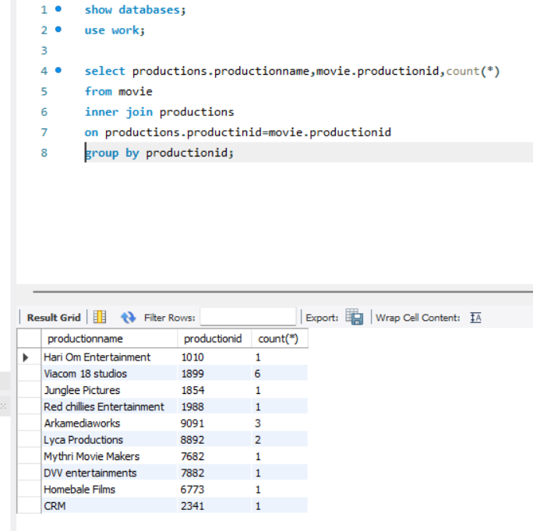

2. Write the query to display production name, owner name have produced more than 2 movies.

>select productions.productionname,movie.productionid,count(\*)

from movie

inner join productions

on productions.productinid=movie.productionid

group by productionid having count(\*)>2;

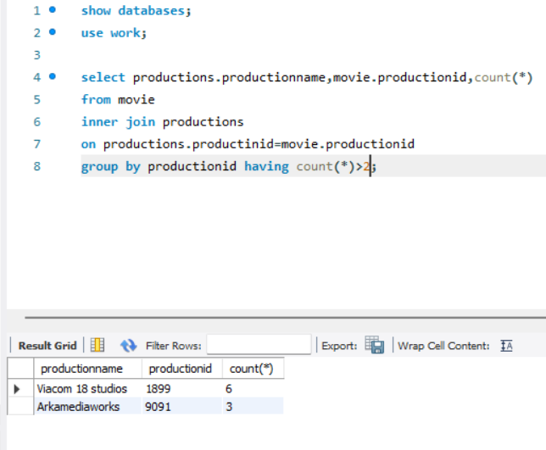

3. Write the query to display production name, owner name have produced maximum movies

>select productions.productionname,productions.ownername,count(\*)

from movie

inner join productions

on productions.productinid=movie.productionid

group by productionid

order by count(\*) desc

limit 1;

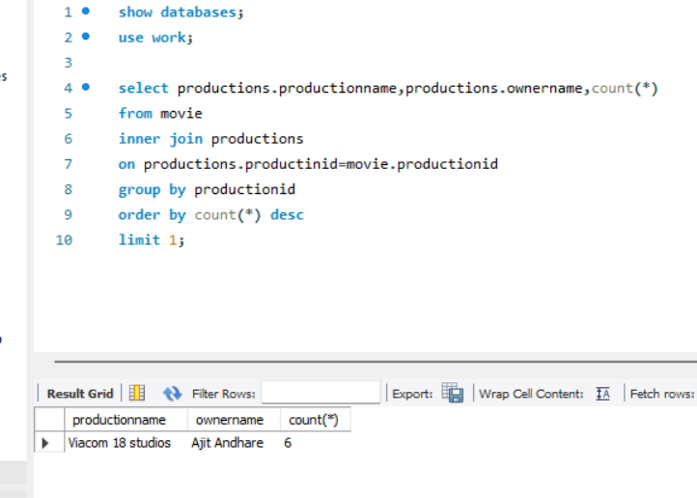

4. Write the query to display the moviename, heroname and productionname acted in the producer name= ’Subaskaran’.

>select productions.productionname,movie.moviename,movie.heroname

from movie

inner join productions

on productions.productinid=movie.productionid

where productions.ownername like 'Subaskaran';

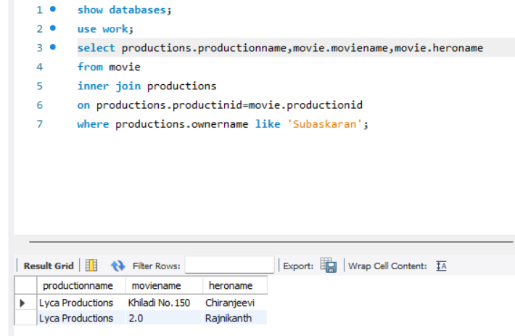

5. Write the query to display the moviename, heroname whose productionid ends with 82.

>select movie.moviename,movie.heroname

from movie

inner join productions

on productions.productinid=movie.productionid

where productions.productinid like '%82';

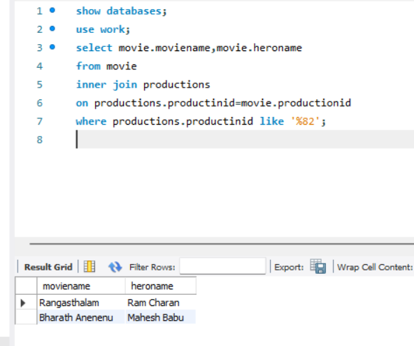

6. Write the query to display the productionname, ownername who has not produced the movie.

>select productions.ownername,productions.productionname

from productions

left join movie

on productions.productinid =movie.productionid

where movie.productionid is null;

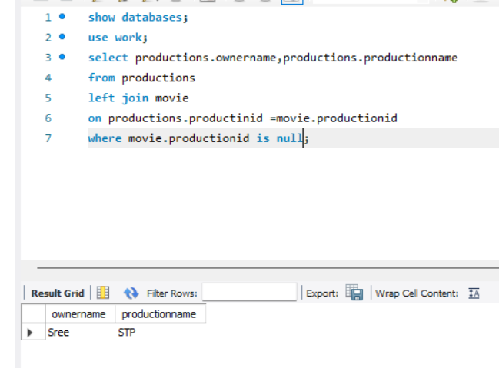

7. Write the query to display the productionname, ownername who has not produced the ‘hindi’ movie.

>select productions.ownername,productions.productionname

from productions

left join movie

on productions.productinid =movie.productionid

where not language='hindi'

group by ownername;

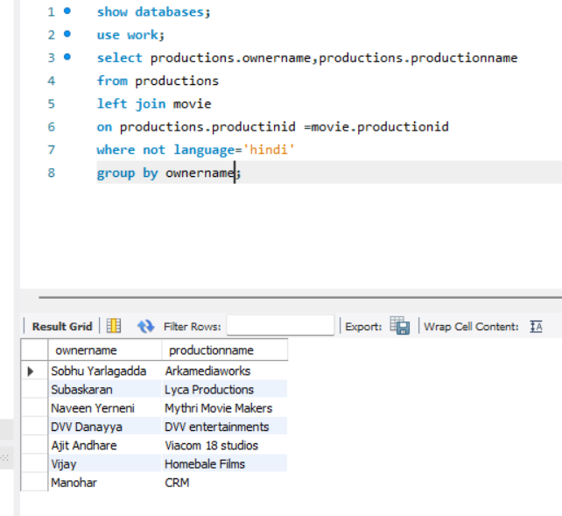

8. Write the query name to display the heroinename who acted in the different productions but not in same production id.

Ans: Amy

>select heroine

from movie

group by heroine having count(heroine)=2;

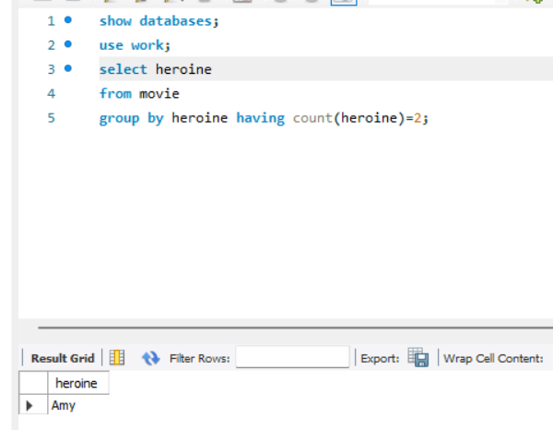

9. Write the query to display the heroname who acted in maximum languages.

>select movie.heroname,count(\*)

from productions

right join movie

on productions.productinid =movie.productionid

group by language,heroname

order by count(\*) desc

limit 1;

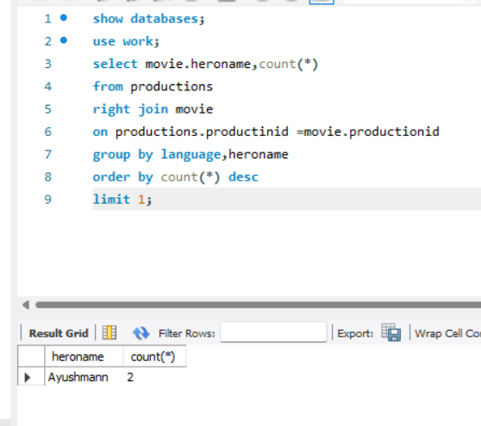

10. Write the query to display the production name, owner name who has produced movie for more languages.

>select productions.productionname,productions.ownername,count(\*)

from productions

right join movie

on productions.productinid =movie.productionid

group by language,productions.productinid having count(\*)>1;

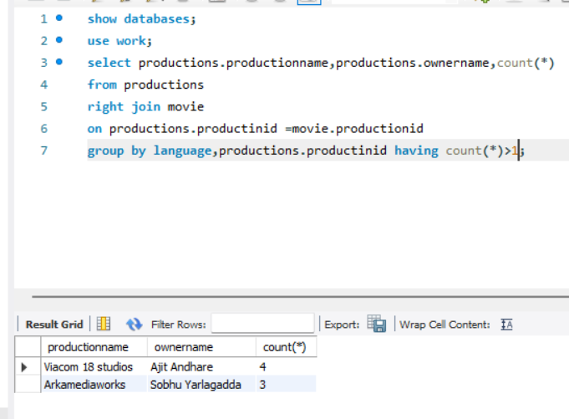

11. Write the query to display the productionname, producername who has not produced any movie.

> select productions.ownername,productions.productionname

from productions

left join movie

on productions.productinid =movie.productionid

where movie.productionid is null;

